DIVYA LOTHE

ELEX DOMAIN

ROLL NUMBER 10

TEMPERATURE CONTROLLED DC FAN

LOW TEMPERATURE

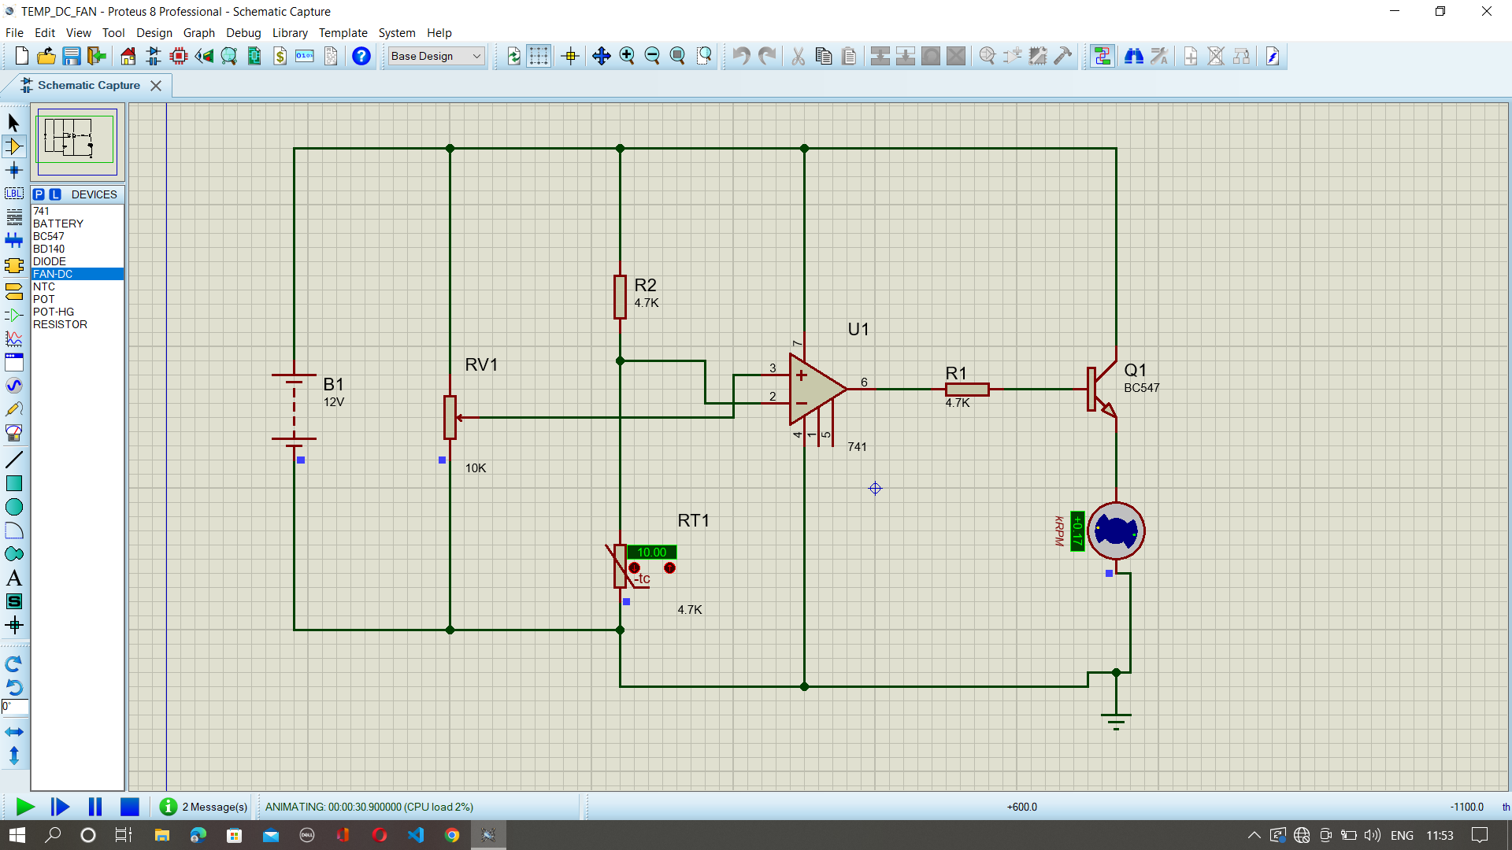

ON INCREASING TEMPERATURE

